Bug 1: Incorrect Calculation of Fines

**Description:**

When a book becomes overdue by one day, no fine is imposed.

**Menu:**

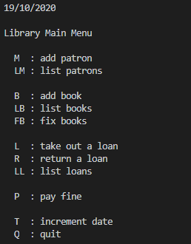

**Inputs:**

**Purpose:** Book Creation

|  |  |
| --- | --- |
| **Prompt** | **Input** |
| Choice : | b |
| Enter author: | Robert Muchamore |
| Enter Title: | The Recruit |
| Enter call number: | 911 |

**Outcome:** Book Created Successfully;

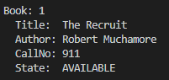

**Purpose:** Patron Creation

|  |  |
| --- | --- |
| **Prompt** | **Input** |
| Choice : | m |
| Enter last name: | Nyberg |
| Enter first name: | Cameron |
| Enter email: | test@test.com |
| Enter phone number: | 911 |

**Outcome:** Patron Created Successfully;

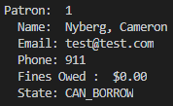

**Purpose:** Borrow Book

|  |  |
| --- | --- |
| **Prompt** | **Input** |
| Choice : | l |
| Swipe patron card (press <enter> to cancel): | 1 |
| Scan Book (<enter> completes): | 1 |
| Commit loans? (Y/N): | y |

**Outcome:** Book Borrowed Successfully;

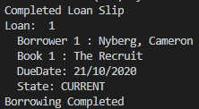

**Purpose:** Bug Replication

**Note:** The due date listed previous is ‘21/10/2020’, with the current date listed as ‘19/10/2020’. An ‘increment date’ (of three days) is therefore required, in order to meet the use case of a book overdue by one day.

|  |  |  |
| --- | --- | --- |
| **Prompt** | **Input** | **Outcome** |
| Choice : | t | Increment days selected |
| Enter number of days: | 3 | Date incremented by 3 |
| Choice : | r | Return a loan selected |
| Scan Book (<enter> completes): | 1 | Book 1 selected, with an OVER_DATE associated with the attached Loan |

**Outcome:** Overdue book returned, identified as overdue and no fine is associated.

